Trip Management System

Delhi Babu Pokuri

<https://github.com/dpokuri02/Trip-management-db>

07-23-2022

1. **Customer:**

* id is a primary key column to uniquely identify each customer for their details and trips or deals they have booked.
* name is a varchar column to store the name of the individual customer.
* mobile is a varchar column to store the mobile number of the individual customer.
* email is varchar column to store the email id of the customer.
* dob is a date column to store the age details of the individual customer.
* gender is a varchar column to store the gender details of the individual customer.
* Address is a varchar column to store the address details of the individual customer.

1. **Deal:**

* id is a primary key column to uniquely identify the deal booked for the customer by the employee and the services in the deal.
* Date is date column to store the date of the deal booking.
* emp_id is (foreign key) int column to store the employee ref for booking the deal for the individual customer
* cust_id is (foreign key) int column for the customer reference whom the deal is booked.
* service_id is (foreign key) int column which refers to the service entity to give details about the service involved in deal booking.

1. **Service:**

* id is a primary key column to uniquely identify services under the deal.
* start_date is date column when the trip is planned/starting.
* end_date is date column when the trip is completed.
* accommodation_id is (foreign key) int column for the accommodation entity .
* transportation_id is (foreign key) int column for the transportation entity .
* activity_id is (foreign key) int column for the activity entity .

1. **Accommodation:**

* Id is a primary key column to uniquely identify accommodation provider for the deal.
* Name is a varchar column to store the name of accommodation provider.
* Location is a varchar column to store the location/address of accommodation provider.
* Type is a varchar column to store the type of accommodation booked.
* Price is float column to store the cost of accommodation booked.

1. **Transportation:**

* id is primary key column to uniquely identify transportation provider for the deal.
* to is a varchar column to store the name of starting place for the trip.
* from is a varchar column to store the name of ending place for the trip.
* type is a varchar column to store the type of transportation booked.
* price is float column to store the cost of transportation booked.

1. **Activity:**

* Id is primary key column to uniquely identify activity provider for the deal.
* Location is varchar column to store the location/address of activity.
* type is varchar column to store the type of activity booked.
* price is float column to store the cost of activity booked.

1. **Package**:

* id is primary key column to uniquely identify payment details for the deal.
* service_id is (foreign key) int column which refers to the service entity to give details about the service involved in deal booking.
* total_discount is float column provide the discount offered.
* total is float column to store the cost of the trip after discount.
* payment_type is varchar column to store the type of payment done.

1. **Employee**:

* id is a primary key column to uniquely identify each employee working in the company.
* name is a varchar column to store the name of the individual employee.
* mobile is a varchar column to store the mobile number of the individual employee.
* email is varchar column to store the email id of the employee.
* department is varchar column to store the department of the employee

1. Will be using the data in analysis of top visiting hotels and top destination and most preferred activities organised by the organiser but joining services tables with the transportation, accommodation and activity entities.
2. Will use the data to suggest to client about the like destinations for the previous history of his selection by joining customer with deals and services previously used.
3. I am trying to suggest or provide the best deals with in the budget for the customers by aggregating the data available.
4. Customer and deal has one to many relationship as a customer can book multiple deals but a deal will have only one customer related to it.
5. Service and deal have one on one relationship as every deal request a different service request.

**UML diagram:**

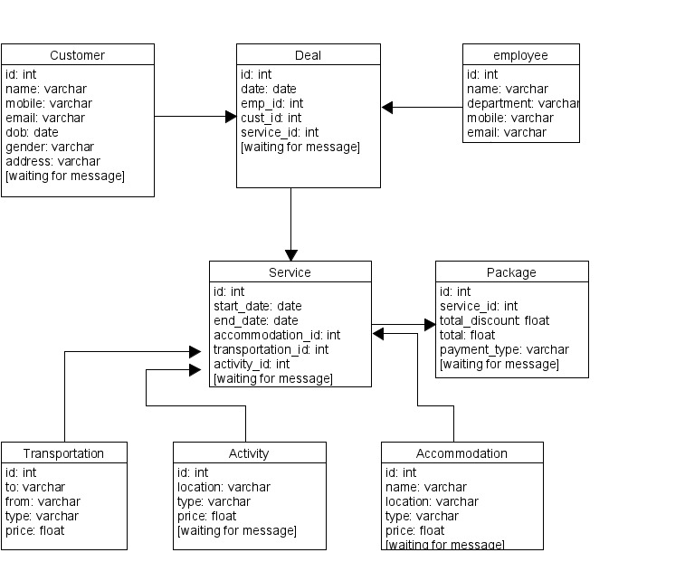

**VERTEBLO diagram**

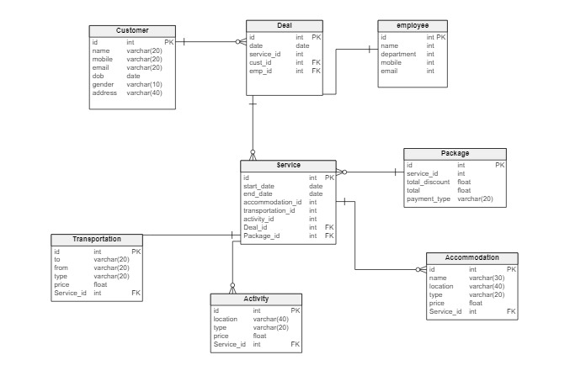

**Use case diagram by UMLET Tool**

